Curriculum Vitae

Personal Details

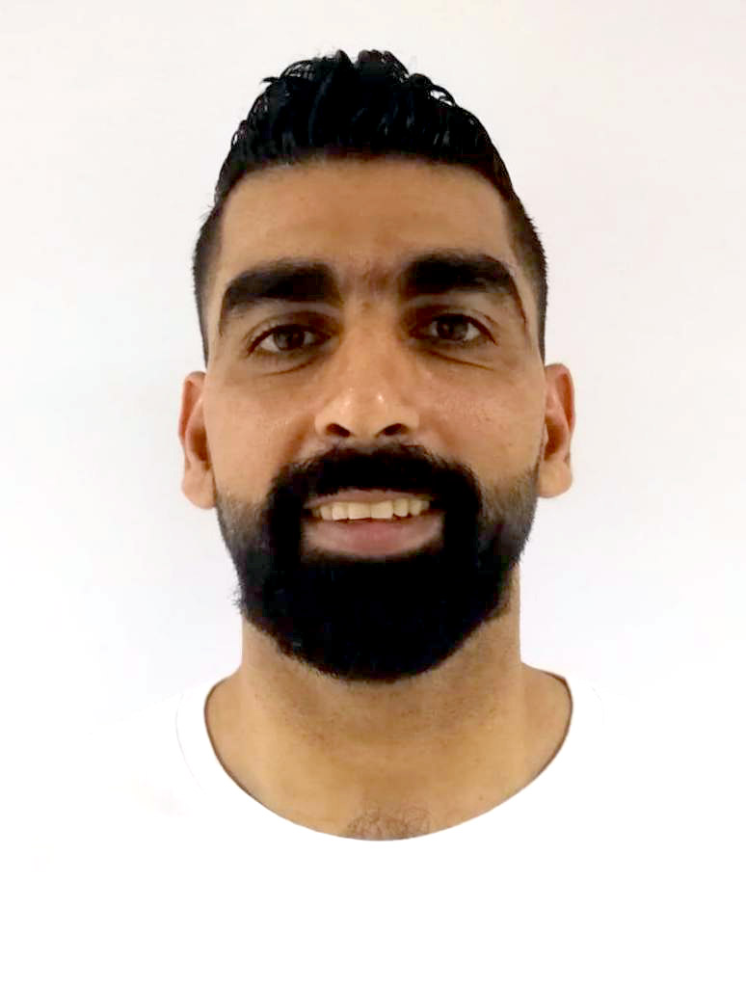
- Name Mohamed Ali Ahmed Jawad Fardan

photo
- Address Home:3556 ,Road:1983 ,
Block: 1019 Dimstan.
- Date of Birth 23/01/1983
- Nationality Bahraini
- Marital Status Married
- Telephone 39077033 / 39919819 / 17600996
- CPR No 830107274

Educational Qualification

- 2000 Al-Jabriya secondary industrial boys school

working Experiences

- Kano Auto Repairing
- Painting Center
- Muharraq Angnier
- Security in gulf pearl hotel

key skills

- Languages: Arabic and English.

